All KS2
Y3/4
Y4/5
Y5/6
 |  | Autumn |  | Spring |  | Summer
KS2 | Topic | Polar regions (Arctic/Antarctic, including polar exploration, habitats etc) |  | Local history-  Banbury Canals (+industrial revolution for 5/6) |  | Climate Change
 | Core Texts & writing opportunities. | Shackleton’s Journey-  - Diary entries  - Letter writing  - Link to Ice Trap (below)  - Biography as Shackleton  - Newspaper article about departure  - Relative clauses, adverbials, brackets, dashes, commas, passive voice (Year ⅚ grammar)  Sky Song-  - Link to whole class reading- VIPERS  - Setting/character descriptions  - Exploring word meanings/evaluating why characters have chosen words/phrases  The Abominables-  - Word meaning ‘abominable’ (front cover, elicitation).  - Postcard for the Yeti’s to remember their time in their new habitat.  - Information reports about Yetis (throughout story, collect facts about Yetis).  - Write a story for the Yeti’s to read (known story/retell or create own) (p10-11).  - Instructions to teach the Yeti’s manners (p11-12).  - Introduction to dialogue between the Yetis.  - Character descriptions of Yetis or of the family (Grandma, Otto etc).  - Letter to stop luxury hotel from being built (anonymous so as not to give herself away), as Agatha doesn’t want the Yeti’s to be discovered.  - Big Write: how to sneak a Yeti back into England. | The Wild Robot-  - Story openings (powerful verbs, adverbs, language of action).  - Writing story opening of being in the middle of fierce weather (p1-2).  - (p7) The Robot – creating own robot hatching.  - Explanation for how to do something/ programming the robot for something never done before (p13) (Link to book ‘Until I Met Dudley’).  - Paragraph innovation (p19) e.g. “if you stand in a classroom for long enough… eventually…”  - Mountain description (p21-23) – exploring the power of description.  - Diary account of the robot.  - Adventure story for something that happened to Roz on the island.  - Author talking to the reader (p26).  Tin Forest-  - Setting description from the animal’s point of view.  - Travel brochure for the new forest.  - Invitations for new people to come to forest.  - Linked to Tree poetry (see below).  - Text innovations for descriptive writing.  Max & The Millions-  - exploring dialogue  - character descriptions  - unpicking vocabulary used and explaining why author chose to use (e.g. turns pale).  - “finds a tiny little boy…” continuing the narrative. | The Lion, The Witch & The Wardrobe (continued)-  - Local history link (C.S Lewis local author).  - Letter home (evacuees)  - Travel guide for Narnia  - Character description, speech, dual narrative.  A Natural History of Mermaids (or) Magical Beasts-  - Not writing about mermaids, rather looking at the style of the text (letter writing, diary accounts, information presentation).  - Using IT to research animals/things to write about.  The Graveyard Book-  - Exploring different narrative styles within texts, and to compose texts with differing narration styles.  - “‘There was a hand in the darkness, and it held a knife…” How does this set the tone for the rest of the novel?  - Does humour play a role in the story? How? | Varjak Paw-  - Persuading Varjak Paul to go outside (p42).  - Describing ordinary object (e.g. hoover, washing machine) to Varjak Paul, personification (p63-64).  - Description of a walk (p86) as a cat walking around CRPS (5 senses).  - (7 skills explained throughout the text – rewrite as information text about what they are and how can be used. Instructions?  - Dialogue: argument between cats? Lots of cat gangs.  - Story: a new chapter for Varjak & Holly.  Tyger-  - Diversity, complex  - Literacy Shed unit for ideas  - Creative writing: exploring wishes and dreams for the future (letter to themselves to be sent to them in a year’s time). | Great Adventurers-  - Links to great explorers (p10-13) – Antarctic  - Graphic novel/information novel of a journey/comic strip exploring Arctic.  - Recount – graphic novel (p12-13).  - Information- a journey into the arctic (p10-11).  The Origin of Species-  - (link to evolution Science topic)  - biography of Charles Darwin  - diary entry- Galapagos travels- including setting description  The Lost Whale-  - Fact file/Non-chronological report on favourite animal (research using laptops)  - Persuasive writing- save the whales (Year ⅚)  - non-chron report on whales/whale hunting (4/5/6)  - Diary entry/recount for whale watching/befriending the whale to send to Mum.
 | Poetry | Cold Mountain-  - Opening doors unit  - Metaphors  Tree by James Carter-  - Layout/concrete poems  - Writing own poem with similar structure (concrete nature poem)  Slowly (Bob Cox)-  - See Tracy for opening doors book/discuss planning. |  | The Tyger by Willaim Blake (linked to Varjak Paul novel)  The Hippocrump (Bob Cox)- |  | Daddy Fell into The Pond-  The Mystery of The Lonely Merman (Bob Cox unit)-
 | Spelling | See Below for Y3/4 & Y5/6 SPAG Progression.
 | Reading Spine | Ice Trap  Sky song  The Girl of Ink and Stars  Cogheart  The Wolf Wider  Scribbleboy  King of the Cloud Forest  Boy at the Back of the Class  Arrival  The Explorer  The Polar Bear Explorer’s Club  Accidental Prime Minister  The Witches  Dominic Grew Sweetcorn  You Are Old Father William  Revolting Rhymes  The Snow Queen  The Mysteries of Harris Burdlick  Winnie The Pooh  Catch A Little Rhyme  A Bear Called Paddington  Charlotte’s Web  Duck’s Ditty

Year 3 & 4- 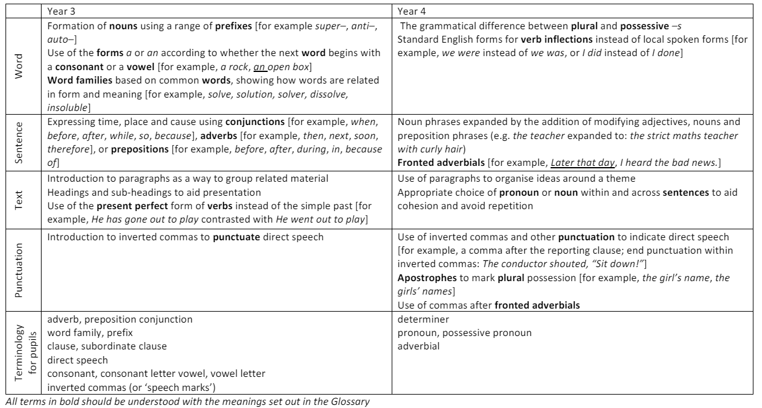

Year 5 & 6-

